* **What is Angular? What are Angular advantages? What the use of Angular?**

Angular is a component based framework or JavaScript binding framework, which binds HTML UI with JavaScript model for building structured, scalable and single page application for client side with the help of routing.

Advantage:

Relatively simple to build SPA with help of component-based application.

To make flexible and structured applications.

Cross platform and open source.

Reusable code.

Testability with help of specs.ts

* **What is the difference between AngularJS and Angular?**

|  |  |
| --- | --- |
| **Angular JS** | **Angular** |
| 1. It only supports JavaScript. | It supports both JavaScript and TypeScript. |
| 2. This framework has a model-view-controller (MVC) architecture. | This framework has a component-based architecture. |
| 3. It does not have a CLI tool. | It has a CLI tool. |
| 4. It does not use Dependency Injection. | It uses Dependency Injection. |
| 5. It does not support mobile browsers. | It also supports mobile browsers. |
| 6. It is not so fast. | It is very fast. |

|  |  |  |
| --- | --- | --- |
| **Feature** | **AngularJS** | **Angular (2, 4, 5, 6, 7, 8, and 9 IVY)** |
| **Language** | JavaScript | TypeScript |
| **Architecture** | Controller | Component |
| **Mobile compliant** | No | Yes |
| **CLI** | No | Yes |
| **Lazy loading** | No | Yes |
| **SEO** | No | Yes |
| **Server side** | No | Yes |

* **Explain the importance of NPM and Node_Modules folder?**

NPM is a package manager which makes installation of JavaScript library along with more free libraries.

Node_modules folder where all the packages are installed.

* **What is CLI tool?**

Is a command line interface by which we can create Initial angular Project.

npm install @angilar/cli

This CLI will give whole component structure format

* **Explain the importance of Package.json file in Angular?**

It has all the reference of javascript references needed for the project.

* **Explain the importance of Component and Modules?**

Components are the most UI building block of a angular app.

* **What is selector?**

A selector is used to identify each component uniquely into the component tree.

* **What is a template?**

Template is an HTML view of Angular in which we can write directives.

Two types (inline and separate physical HTML file.)

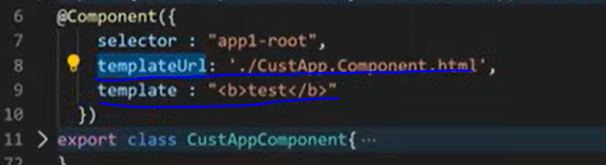

* **What is a module & what is app.module.ts?**

Module is a place where you can group the components, directives, pipes and services which are related to the application.

* **How an Angular App gets Loaded and Started? What are index.html, app-root, selector and main.ts?**

Angular is used to create Single Page Applications. index.html file is that single page. Index.html will invoke main.js file which is the JavaScript version of main.ts file.

main.ts file is like the entry point of the web app. It compiles the web app and bootstraps the AppModule to run in the browser.

App module file will then bootstrap the AppComponent.

AppComponent or app-root component is the HTML which you will see finally.

* **What is a Bootstrapped Module & Bootstrapped Component?**

When the Angular web application starts, the first module launched is the bootstrapped module, and the same is true for the bootstrapped component also.

* **What is Data Binding in Angular?**

Databinding is the communication between typescript view and the component of HTML view.

* **What is String Interpolation in Angular?**
* **What is Property Binding in Angular?**

**INPUT DATA**

**Interpolation** - one-way data-binding technique that is used to transfer the data from a **TypeScript code (component)** to an **HTML template (view).**

**It will work only with string type.**

**It is represented only inside bouble braces.** {{data}}

**Property Binding** - One-way binding from to transfer the data from a **TypeScript code (component)** to an **HTML template (view).**

**It** **is a** **superset of interpolation**.

**it can set an element property to a non-string data.** [property] =”data”

* **What is Event Binding in Angular?**

**OUTPUT DATA**

**Event Binding** - (event) =”expression”→ One-way binding from UI to the component

* **What is Two way Binding in Angular?**

**TWO WAY DATABINDING**

**Two-Way Binding** - Two-way data binding in Angular will help users to exchange data from the view to component and then from component to the view at the same time

[(ngModel)] =”data”→

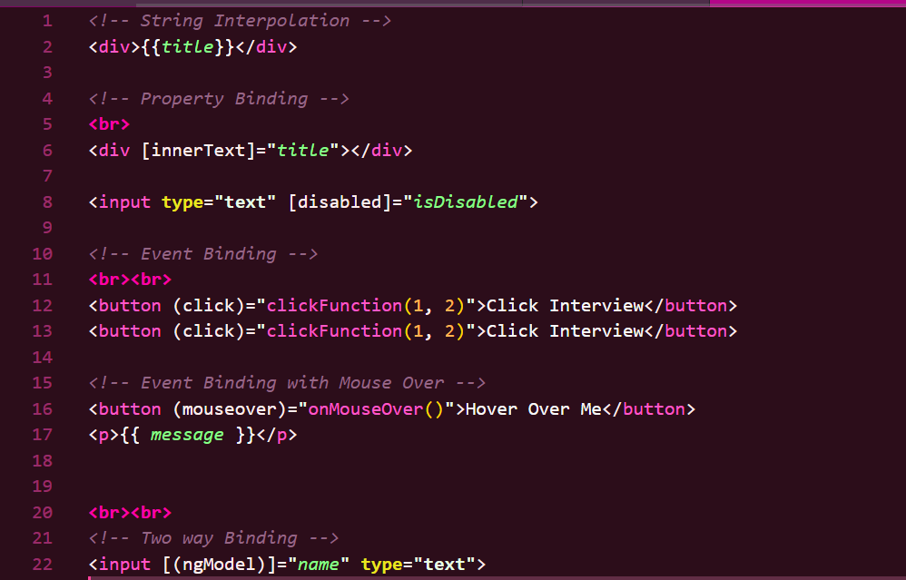

* **What are directives in Angular? and different types of Angular directives?**

Directives are classes that add additional behaviour to elements.

Angular syntax which can write inside HTML, so that we can change the behaviour of HTML DOM.

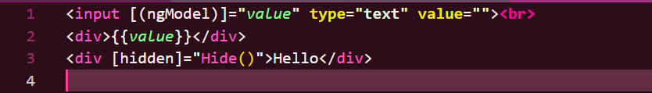

Angular has three types of directives:

1. Component Directives (Most Common) → Customized user control. Directives with template (@Component)
2. Structural Directives → Change the DOM layout by adding or removing elements. (*ngIf, *ngFor, *ngSwitch)
3. Attribute Directives → Modify the appearance or behaviour of an HTML element ([ngClass], [ngStyle], Custom directives)

* **What is *ngIf Structural directive?**

To display elements conditionally

example:

On click of hide button it should hide and vice versa.

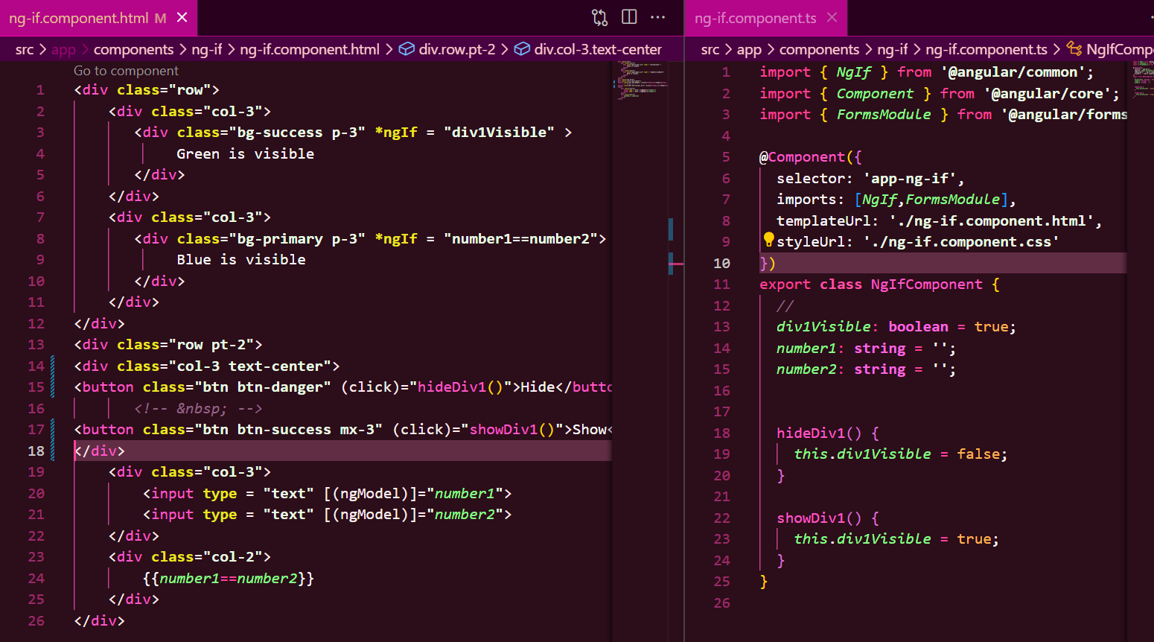

Another example

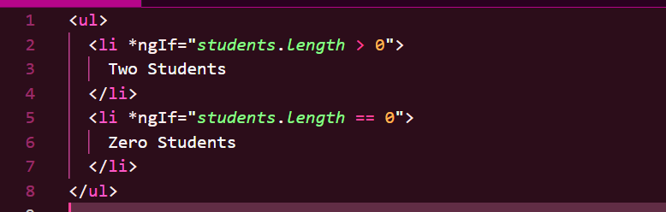

* **What is *ngFor Structural directive?**

To iterate a list of items.

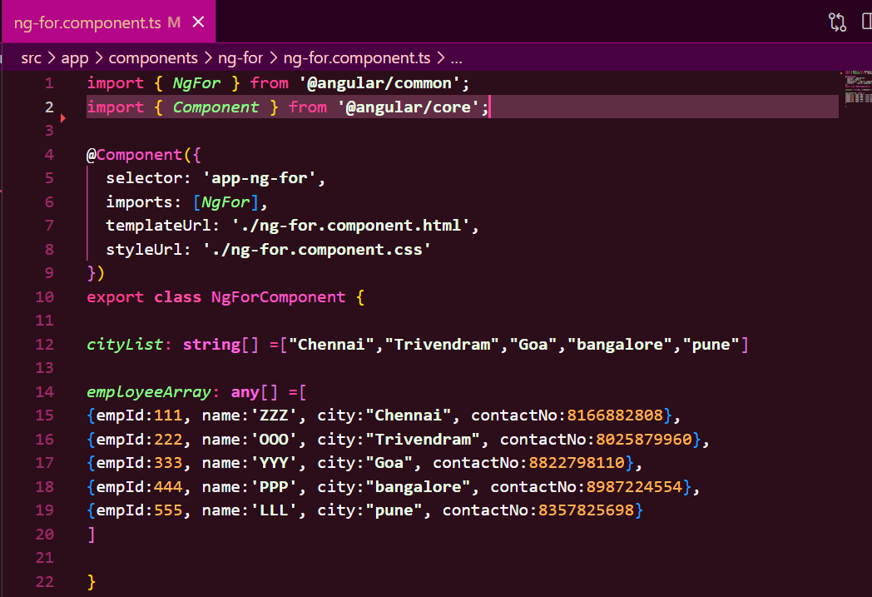

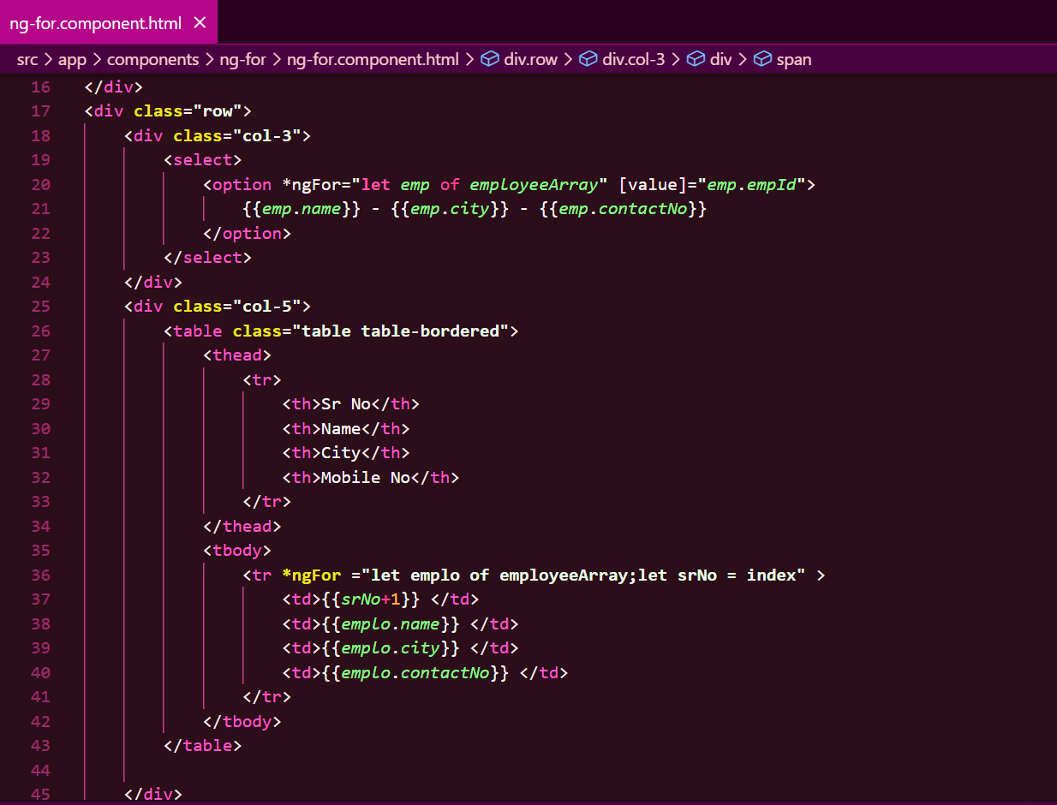

* **What is *ngSwitch Structural directive?**

Used in combination with *ngSwitchCase and *ngSwitchDefault

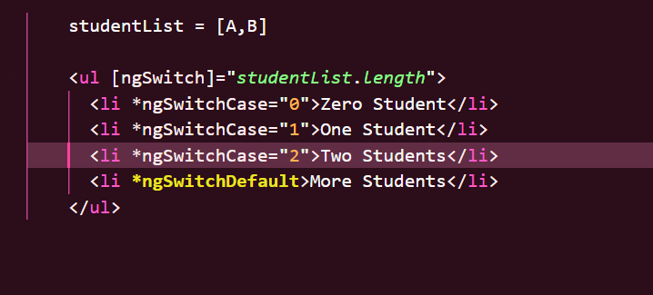

* **What is [ngStyle] Attribute directive?**

It updates the style for the HTML element.

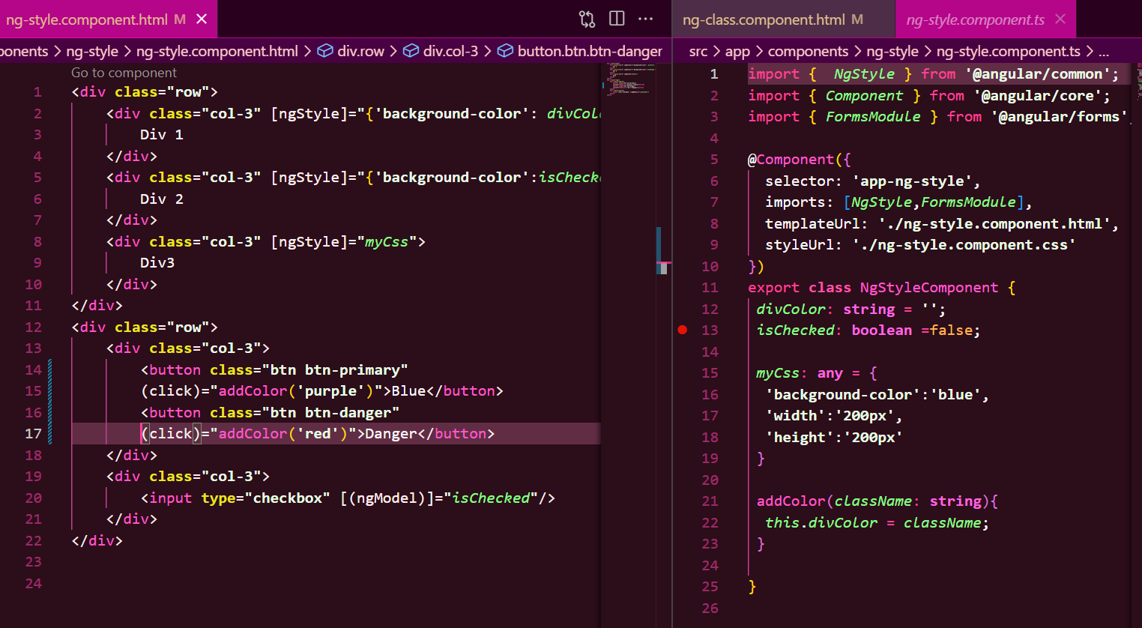

* **What is [ngClass] Attribute directive**

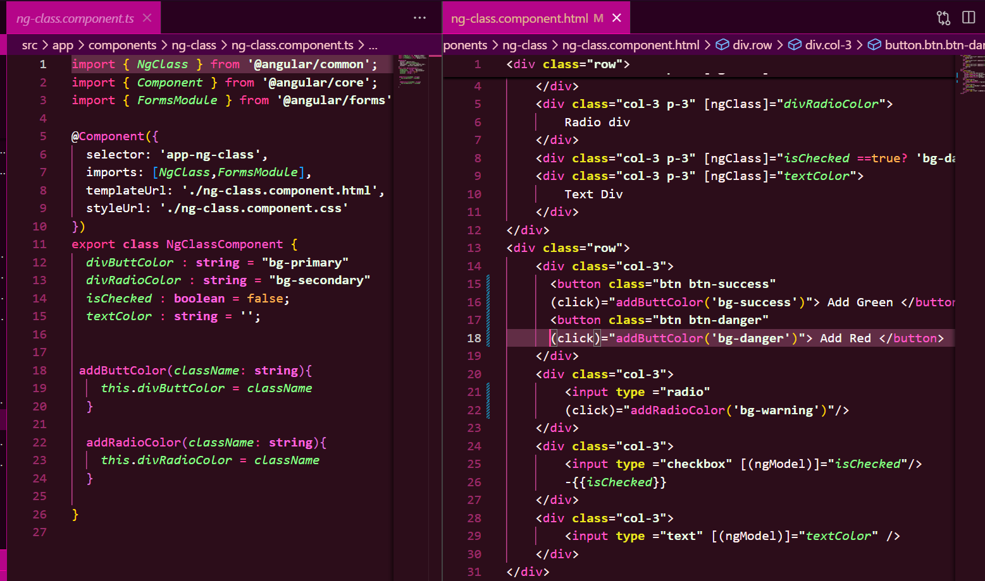

* **What is the difference between Component, Attribute and Structural Directives?**
* **What is Decorator?**
* **What are the types of Decorator?**
* **What is a decorator in Angular? Or What are Annotation or Metadata?**

Defines what king of angular class it is..

@component denotes Angular component.

@NgModule denotes Angular Module

* **What are Pipes? What are the types of Pipes & Parameterized Pipes?**
* **What is Chaining Pipes?**
* **Explain architecture of Angular?**

**⬇️ User Clicks a Button**

**┌──────────────────────────────────────────┐**

**│ COMPONENTS (UI + Logic) │**

**│ - app.component.ts (Controller) │**

**│ - app.component.html (View) │**

**└──────────────────────────────────────────┘**

**⬇️ Calls Service**

**┌──────────────────────────────────────────┐**

**│ SERVICES (Business Logic) │**

**│ - Fetch data from APIs │**

**│ - Perform calculations │**

**└──────────────────────────────────────────┘**

**⬇️ Uses DI to Fetch Data**

**┌──────────────────────────────────────────┐**

**│ DEPENDENCY INJECTION (DI) │**

**│ - Inject services into components │**

**└──────────────────────────────────────────┘**

**⬇️ Updates the UI**

**┌──────────────────────────────────────────┐**

**│ DIRECTIVES & PIPES │**

**│ - *ngIf, *ngFor (Structure) │**

**│ - ngClass, ngStyle (Styling) │**

**│ - Pipes (Data Transformation) │**

**└──────────────────────────────────────────┘**

* **What is SPA in Angular?**

SPA is single page Application where the main UI gets loaded ay once and the needed UI gets loaded on need.

* **How to implement SPA in Angular?**

We have to use Angular routing, Routing is a simple collection in Angular.

* **How to implement routing in Angular?**
* **Explain Lazy Loading ?**
* **How to implement Lazy Loading in Angular?**
* **Explain Services with Example?**
* **How to create Servicein Angular?**

* **Differentiate between ng Serve and ng build?**
* **Explain the --prod parameter in ng build ?**
* **What is Depedency Injection?**
* **How to implement Depedency Injection?**
* **What’s the benefit of Depedency Injection?**
* **How to use Dependency Injector with Services in Angular?**
* **What is Hierarchical Dependency Injection?**
* **What is Provider in Angular?**
* **What is the role of @Injectable Decorator in a Service?**
* **What are Parent-Child Components?**
* **What are Lifecycle Hooks in Angular?**
* **What is a Constructor in Angular?**
* **What is ngOnInit life cycle hook in Angular?**
* **What is the difference between constructor and ngOnInit?**
* **What are Asynchronous operations?**
* **What is the difference between Promise and Observable?**
* **What is RxJS?**
* **What is Observable? How to implement Observable**
* **What is the role of HttpClient in Angular?**
* **What is typescript and why do we need it?**

It adds types to JavaScript or superset of JavaScript.

* **What is Typescript? Or What is the difference between Typescript and Javascript?**
* **What is the difference between let and var keyword?**
* **What is Type annotation?**
* **What are Built in/ Primitive and User-Defined/ Non-primitive Types in Typescript?**
* **What is “any” type in Typescript?**
* **What is Enum type in Typescript?**
* **What is Type Assertion in Typescript?**
* **What are Arrow Functions in Typescript?**